

AHU CONTROLLER TEST DATA SHEET

P/N: N_A Date: 15/04/2018

S/N: N_A Time: 13:13

UA: N_A Tested by: user

Hardware Rev: BLDC_60A_V6 Approved by: user

Software Rev: N_A

Tester Software Version: 1.2k

Equipments Used

Equipments Model No Serial No

Power Supply

Digital Multimeter

CAN Interface

BLDC Tester

PC

Heater

RS-232 Interface

Current Meter

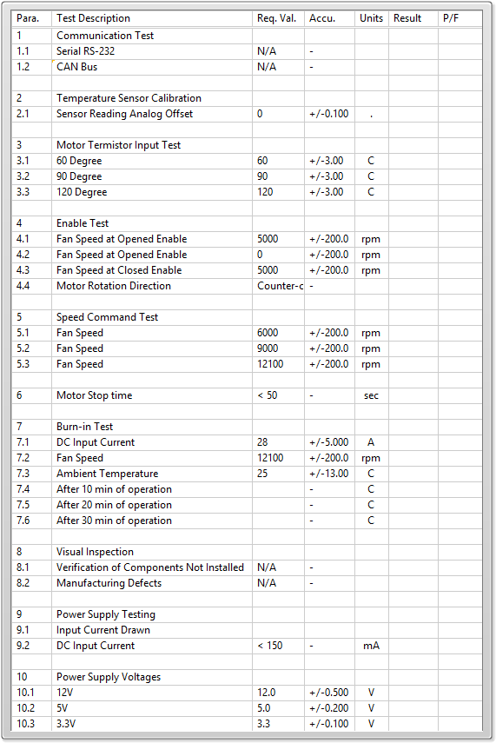

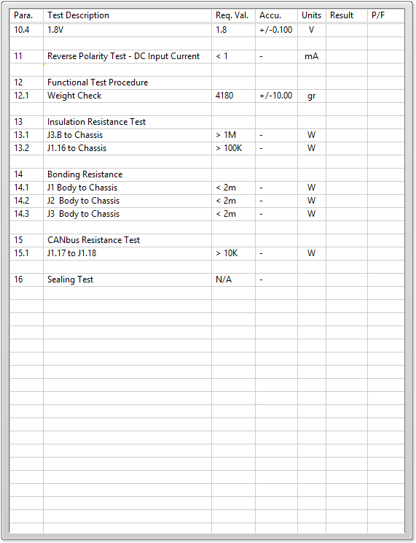

General result:

Test-Operator:____ user_________ Q.A.:__________________________